**Report about best devices & OS & programming languages & database and applications.**

**System Name:**

1. **Devices**

**Pcs :**friendly for user and using

1. **Operating Systems**

**Windows 10/11 :**best platform and friendly

1. **Programming Language**

C# use to create applications

Html

1. **Database**

**MySql**

**Microsoft Sql server**

1. **Applications**

**Visual studio / Visual studio Code**

**Bootstrap**

There are support mvc to creae a design

**https://github.com/salma0ayman77/Proo.git**

**Design of an integrated system (Class diagram)**

**Task**

Id Primary Key

Title

Description

Status

Priority

Deadline DateTime

ProjectId Foreign Key

TeamMemberId Foreign Key

**Project**

Id Primary Key

Name

Description

StartDate DateTime

EndDate DateTim

**TeamMember**

Id Primary Key

Name

Email

Role

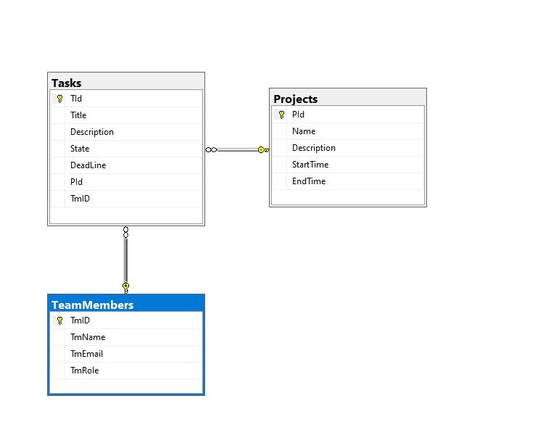

**Testing**

|  |  |  |  |  |  |  |
| --- | --- | --- | --- | --- | --- | --- |
| **Test case ID** | **Test case description** | **Test Steps** | **Test Data** | **Expected Result** | **Actual Result** | **Pass/Fail** |
| 1 | Create page that allow to the user to put his data and include to the index page | When I run the code I write in the url /project/create | Name=Pro1 ,DEscription =sss | pass | pass | pass |
| 2 | Create button update that if the user want to update his data | That to update the data | updating the data | pass | pass | pass |
| 3 | Create action delete | That to delete the data | Delete data | pass | pass | pass |
| 4 | Create details action | That show all data from task | View | pass | pass | pass |
|  |  |  |  |  |  |  |
|  |  |  |  |  |  |  |